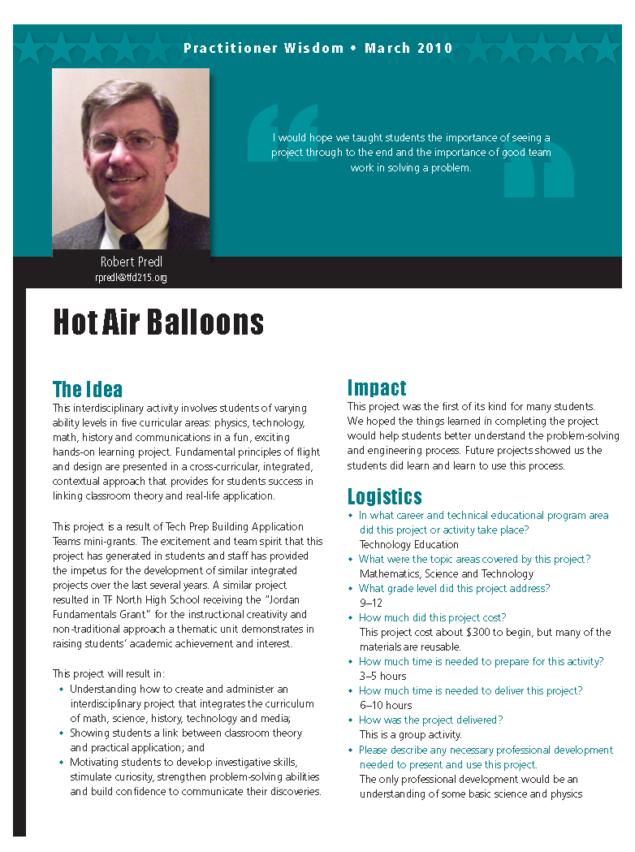
Practitioner Wisdom Practice – The Hot Air Balloon Project

The Hot Air Balloon Project, an interdisciplinary activity, involves students of varying ability levels in five curricular areas: physics, technology, math, history and communications in a fun, exciting hands-on learning project. Fundamental principles of flight and design are presented in a cross-curricular, integrated, contextual approach that provides for students success in linking classroom theory and real-life application.

This project helps teachers better understand how to create and administer an interdisciplinary project that integrates the curriculum of math, science, history, technology and media; shows students a link between classroom theory and practical application; and motivates students to develop investigative skills, stimulate their curiosity, strengthen their problem-solving abilities and build confidence in communicating their discoveries.

Download Project Overview

Listen to the companion podcast (transcript – PDF).

Related Instructional Materials:

Aerostatic Design Principles for Paper Hot Air Balloons (.doc)
Box Balloon (.doc)
Build Your Own Hot Air Balloon (.doc)
Building and Flying Paper Hot Air Balloons (.doc)
Building Your Own Hot Air Balloon (.doc)
Density Assessment (.doc)
Density Experiment (.doc)
Density Practice (.doc)
Density Research (.doc)
Density Rubric (.doc)
Density Student PowerPoint (.ppt)
How Stuff Works (.doc)
How to Calculate the Weight of Air and Model Hot Air Balloon (.doc)
Launcher
Plans for Building Model Hot Air Balloons - Links (.doc)
The Question (.doc)
Volume Calculations for Cylinder Shaped (.doc)
Hot Air Balloon Project - All Files (.zip)

Related Reports:

NRCCTE Curriculum Integration Workgroup. (2010, March). Capitalizing on context: Curriculum integration in career and technical education. Louisville, KY: National Research Center for Career and Technical Education, University of Louisville. (PDF)

Stone, J. R., III, Alfeld, C., Pearson, D., Lewis, M., & Jensen, S. (2007). Rigor and relevance: A model of enhanced math learning in career and technical education. St. Paul, MN: National Research Center for Career and Technical Education. (PDF)

Lewis, M. V., & Pearson, D. (2007). Sustaining the impact: Follow-up of teachers who participated in the Math-in-CTE study. St. Paul, MN: National Research Center for Career and Technical Education. (PDF)
Stone, J. R., III, Alfeld, C. Pearson, D., Lewis, M. V., & Jensen, S. (2006). Building academic skills in context: Testing the value of enhanced math learning in CTE (Final study). St. Paul, MN: National Research Center for Career and Technical Education. (PDF)
Stone, J. R., III, Alfeld, C. Pearson, D., Lewis, M. V., & Jensen, S. (2005). Building academic skills in context: Testing the value of enhanced math learning in CTE (Pilot study). St. Paul, MN: National Research Center for Career and Technical Education. (PDF)

Related Multimedia:

Maximizing the Academics in CTE: The NRCCTE Curriculum Integration Studies (video; closed captioned)

An Introduction to the Math-in-CTE Curriculum Integration Model (video; closed captioned)

Math-in-CTE at the Arlington Career Center, Arlington Public Schools (video; closed captioned)

Math-in-CTE Sample Lesson: Information Technology (video; closed captioned)

Math-in-CTE Sample Lesson: Aircraft Weight and Balance (video; closed captioned)

Math-in-CTE Video Series Webinar (video; closed captioned)

